**ABSTRACT**

As a name specifies “HOLIDAY TOURS” is software developed for travelers to reserve their trip through online. Online booking are increasing rapidly these days, there by demand for such websites are also increasing and hence travelers prefer safe travel agencies for their trip.

Travel is moment of people between relatively distant geographical locations, and can involve travel by foot, bicycle, automobile, bus, train, airplane, or other means, with or without luggage and can be one way or round trip.

Travel can also include relatively stay between successive moments. Reason for travelling include recreation, tourism, or vacationing, research travel, the gathering of information, visiting people, volunteer travel for charity, migration to begin life somewhere else, religious pilgrimages etc..

**CONTENT**

**1 Introduction……………………………………………………………… 3**

**2 System Analysis…………………………………………………………. 5**

**2.1 Literature Survey………………………………………………. 5**

**2.2 Proposed System…………………………………………….... 6**

**2.2.1 Scope of the Project…………………………………. 6**

**2.2.2 Aim of the Project…………………………………… 6**

**3 Requirement Specification………………………………………………. 8**

**3.1 System Requirement…………………………………………... 8**

**3.1.1 Hardware Requirement……………………………… 8**

**3.1.2 Software Requirement………………………... 8**

**3.2 Development Environment……………………………………. 10**

**4 System Design…………………………………………………………… 13**

**4.1 E R Diagram…………………………………………………… 13**

**4.2 Schema Diagram………………………………………………. 14**

**5 System Implementation………………………………………………….. 15**

**5.1 Modules Description………………………………………….... 15**

**6 Sample Output Screenshots……………………………………………... 19**

**7 Conclusion……………………………………………………………… 31**

**8 Bibliography**

**Chapter 1**

**INTRODUCTION**

Holiday Tours concept was introduced during 90's. The site contains vast database of points of interest, restaurants and tour often enhances with user reviews.

Holiday Tours is a confidential seller/public service that present tourism related services to the public of behalf of dealers like hotel, package tour, railways, rental car, airlines, and seaways. There are also travel agencies that provide as general sales agents for overseas business, allowing them to have branches in regions and nations other than where their head offices are placed.

Just as sleep is necessary for our body similarly holidays are important for relaxation and change - they provide relief from the monotony of our daily routine. They are important for our mental and emotional wellbeing.

Holidays! Holidays! Holidays who does not wait for them? Holidays give us a break from routine and help us to refresh ourselves and go back to work with renewed energy.

The benefits of travel applicable to working adults, couples, families, and extended family members. While travel is often perceived as an outlet for relaxation, education, and a chance to escape the mundane, recent research suggests that travel has several deeper benefit for families, relationships, and individual. Tourism provides positive benefits for adults, children, and couples. Several studies cited time allotted for family bonding is decreasing, likely attributed to increased carrier demands and changing family structures. These studies further showed travel as a means to utilize limited family time to help improve communication within a relationship, reduce the possibility of divorce, strengthen lifelong family bond, and increase a sense of well-being in adults and children. Gaps in the existent research were noted, and potential suggestions for future research are addressed.

Holidays are not meant for enjoying but also for pursuing our hobbies and interests. During holidays we can live our life as we want.

Agency's major role is to perform as a representative. Promoting travel goods and services on behalf of dealers. Therefore, similar to other retail industries, they don’t have a stock in store. A holiday pack or a ticket is not obtained from a dealer till a consumer desires that purchase. The holiday or ticket is providing to them at money off offer. The revenue is consequently a variation among the marketing cost which it is offered to the agent. This is known as the commission. In countless countries, all persons or companies that trade tickets are necessary to be licensed as a travel agent.

Many British and American agencies license are based on these associations:

(IATA) international transport association-for who issue air tickets.

(ATOL) air travel organizer’s licensing-for who order tickets.

(ABTA) association of British travel agent or the (ASTA) the American society od travel agent, for who trade packet holidays on behalf of a tour company.

**Chapter 2**

**SYSTEM ANALYSIS**

**2.1 Literature Survey**

Literature survey is mainly concern with study of previous research or other author paper in the similar area of study. The survey is organized into sections covering prior work on various aspects present in the subsequent topic. The study had done on customer decision of places, price, attractive offers, amount of time he can spend in trip. Designer must take all the customer wishes into consideration and according to that he has to design the site.

**Places** different age group people prefer different type of places for travel about, likely old age people prefer for spiritual places, young age people prefer hill stations, beaches etc.. as above different people prefer different places for their trip travel agency should provide with variety of packages to fulfill travelers wish, according to the different places the designer should also provide best possible accommodation of traveler and should concentrate to provide a hygienic food for the traveler according to their wish and provide the safety and security for the traveler during trip

**Price** the designer should concern with making the package at affordable cost for all set of people and make sure that design the prices in such way that it must be worth for that trip and choose the mode of travelling which need less price and give the traveler wit al type of prices for single trip and select the good hotel at less price for traveler so that many people were going to choose your site.

**Attractive offer** the designer should design the site in such a way that he should give number of offers for travelers so that these offers make them to motivate for them to travel more and give offers during special occasions and holidays, and give offer for the one who travels regularly so that it makes him to travel often.

**Time a person can spend of traveling** corporate people cannot spend too much time for travel but for their well soul being and for their mind relaxation they need to do trip, to improve the communication with the family members corporate people need to do travel, to improve the relation between the family members they need to travel, designer should design trip duration according to the different people on their available time, select the trip duration for least time that can affordable for all set of people.

**2.2 Proposed System**

**2.2.1 Scope of the project**

Being a traveler you usually dream to travel for your soul, to improve your outlook toward life, and of course, to bring ultimate happiness. If this is the case then don’t you think so that you have to plan it before time? Making some efforts in finding right place to travel. Now, are you wondering that who is going to help you in this regard, Yes!! Holiday Tours is going to help you in al these matter, they help make your trip a Memorable and Happier one. Travel agencies never forces its decision on traveler. Rather the highly professional team mates give you an opportunity to choose from varied multiple itineraries suggestions to finally get a tailor made solution for traveler. Travel agency ensure you that your travel is safe with us. By customized travel package that has made near-all possible ways to save your money. It means you have also saved your time. Otherwise, never ending whirlpool of thoughts that Oh! my trip is near, now whom to contact, what to do, how to save money, would surely have left you no where.

Holiday Tours do solve all these problem of a traveler and make sure that their travel would be memorable and filled with happiness. Rather than searching for hotel, restaurant, home stay, rental car, places etc.. Holiday Tours give you all information in a single site. The vision of Holiday Tours is providing the best of its services to its valued customers.

**2.2.2 Aim of the Project**

A Holiday Tours is a website dedicated to travelling which aims to help the user plan their individual trip to different destinations. The site contains a vast database of points of interest, restaurants and tour often enhanced with user reviews.

Providing a high standard of services suitable for individuals seeking relaxing, comfortable and memorable experiences in the hospitality and tourism industry.

Providing the tourist market with the quality personal required by the tourism industry. Produce expeditions and memories that would satisfy each and every single of the customer.

We believe tourism should help improve the satisfaction and experience of tourist.

**Chapter 3**

**Requirement Specification**

**3.1 System requirements**

**3.1.1 Hardware configuration**

Hardware configuration references the details and system resources setting allotted for a specific device. It is the important concept related to the software development, insufficient random access memory may affect adversely on the speed and efficiency of the whole system.

The processor should be powerful to handle the entire process.

1GB ram(min)

Either Intel core processor or AMD processor

250GB Space(min)

**3.1.2 Software Configuration**

The output of a software process is information that may be divided into three categories

[a]Computer program (both source level and executable level), [b]Work products that describes the computer program (targeted at both technical and end users), [c]Data (contained within the program or external to it).

The items that comprise all the information produced as part of software process are collectively called as software configuration. A major element in building the a system is selection of compatible software since the software in market experiencing in geometric progression selected software should be flexible to all system. This document gives the detailed description of the software requirement specification.

**Frontend-HTTP** Hypertext Transfer Protocol is an application protocol for distributed, collaborative, and hypermedia information systems. HTTP is the foundation of data communication for the World Wide Web. Hypertext is structured text that uses logical links between nodes containing text. Development of HTTP was initiated by Tim Berners-lee at CERN in 1989. Standards development of HTTP was coordinated by the Internet Engineering Task Force(IETF) and World Wide Consortium(W3C), culminating in the publication of series of Request for Comments(RFCs). The first definition of HTTP/1.1, the version of HTTP in common use, occurred in RFC 2068 in 1997, although this was obsolete by RFC 2616 in 1999 and then again by RFC 7230 family in RFCsin 2014. A later version, the successor HTTP/2 was standardized in 2015, and is now supported by major web server and browsers over TLS using ALPN extension[2]where TLS 1.2 or newer is required.

**Backend-MySQL** is an open source relational database management system (RDBMS).

The MySQL development project has made its source code available under the terms of GNU General Public License, as well as under a variety of proprietary agreements. MySQL was owned and sponsored by a single for-profit firm, the Swedish company MySQL AB, now owned by Oracle Corporation. For proprietary use, several paid editions are available, and offered additional functionality. MySQL is central component of LAMP open-source web application software stack. LAMP is an acronym of “Linux, Apache, MySQL, Perl/PHP/Python”. Application that use the MySQL database include TTPO3, MODx, Joomal, WordPress, phpBB, MyBB, and Drupal. MySQL is also used in many high-profile. Large-scale websites, including Google, Facebook, Twitter, Flickr, YouTube.

Operating System Windows 10

|  |  |
| --- | --- |
| [[Screenshot of the default MySQL command-line banner and prompt](https://en.wikipedia.org/wiki/File:Mysql-screenshot.PNG)](https://en.wikipedia.org/wiki/File:Mysql-screenshot.PNG)  [Screenshot](https://en.wikipedia.org/wiki/Screenshot) of the default MySQL command-line banner and prompt | |
| [**Original author(s)**](https://en.wikipedia.org/wiki/Software_developer) | [MySQL AB](https://en.wikipedia.org/wiki/MySQL_AB) |
| [**Developer(s)**](https://en.wikipedia.org/wiki/Software_developer) | [Oracle Corporation](https://en.wikipedia.org/wiki/Oracle_Corporation) |
| **Initial release** | 23 May 1995; 22 years ago |
|  | |
| [**Stable release**](https://en.wikipedia.org/wiki/Software_release_life_cycle) | 5.7.20[[1]](https://en.wikipedia.org/wiki/MySQL#cite_note-mysql_release-1) / 16 October 2017; 37 days ago |
| [**Preview release**](https://en.wikipedia.org/wiki/Software_release_life_cycle) | 8.0.3 rc[[2]](https://en.wikipedia.org/wiki/MySQL#cite_note-2) / 21 September 2017; 2 months ago |
| [**Repository**](https://en.wikipedia.org/wiki/Repository_(version_control)) | <https://github.com/mysql/mysql-server>, <git://anongit.gentoo.org/proj/mysql-extras.git> |
| **Development status** | Active |
| **Written in** | [C](https://en.wikipedia.org/wiki/C_(programming_language)), [C++](https://en.wikipedia.org/wiki/C%2B%2B)[[3]](https://en.wikipedia.org/wiki/MySQL#cite_note-3) |
| [**Operating system**](https://en.wikipedia.org/wiki/Operating_system) | [Windows](https://en.wikipedia.org/wiki/Microsoft_Windows), [Linux](https://en.wikipedia.org/wiki/Linux), [Solaris](https://en.wikipedia.org/wiki/Solaris_(operating_system)), [macOS](https://en.wikipedia.org/wiki/MacOS), [FreeBSD](https://en.wikipedia.org/wiki/FreeBSD)[[4]](https://en.wikipedia.org/wiki/MySQL#cite_note-4) |
| **Available in** | [English](https://en.wikipedia.org/wiki/English_language) |
| [**Type**](https://en.wikipedia.org/wiki/Software_categories#Broad_categories) | [RDBMS](https://en.wikipedia.org/wiki/Relational_database_management_system) |
| [**License**](https://en.wikipedia.org/wiki/Software_license) | [GPL](https://en.wikipedia.org/wiki/GNU_General_Public_License) (version 2) or [proprietary](https://en.wikipedia.org/wiki/Proprietary_software)[[5]](https://en.wikipedia.org/wiki/MySQL#cite_note-5) |
| **Website** | [www.mysql.com](http://www.mysql.com/) |

Fig 3.1 MySQL

**3.2 Development environment**

XAMPP is free and open source cross-platform web server software, released under terms of Apache License 2.0. Apache is maintained by open community of developers under the auspices of Apache Software Foundation. In XAMPPX stands for cross-platform, A stands for Apache, M stands for Maria DB, P stands for PHP, P stands for Perl.

* Developer(s)-Apache Friends
* Initial release-May 22,2002
* Stable release-7.1.11-Windows

7.1.11-Linux

7.1.11-macOS/November 10, 2017

* Operating system-Cross-platform

Linux

Window

Solaris

|  |  |  |
| --- | --- | --- |
|  | | |
| XAMPP | | |
| [Xampp logo.svg](https://en.wikipedia.org/wiki/File:Xampp_logo.svg) | | |
| [XAMPP In Action on OSX.png](https://en.wikipedia.org/wiki/File:XAMPP_In_Action_on_OSX.png)  Fig 3.2 A screenshot of XAMPP running all servers on Mac OS X | | |
| [**Developer(s)**](https://en.wikipedia.org/wiki/Software_developer) | Apache Friends | |
| **Initial release** | May 22, 2002; 15 years ago | |
|  | | |
| [**Stable release**](https://en.wikipedia.org/wiki/Software_release_life_cycle) | 7.1.11 - [Windows](https://en.wikipedia.org/wiki/Microsoft_Windows) 7.1.11 - [Linux](https://en.wikipedia.org/wiki/Linux) 7.1.11 - [macOS](https://en.wikipedia.org/wiki/MacOS) / November 10, 2017; 7 days ago | |
| [**Repository**](https://en.wikipedia.org/wiki/Repository_(version_control)) | <https://github.com/ApacheFriends> | |
| **Development status** | Active | |
| **Written in** | Various Languages | |
| [**Operating system**](https://en.wikipedia.org/wiki/Operating_system) | [Cross-platform](https://en.wikipedia.org/wiki/Cross-platform) [Linux](https://en.wikipedia.org/wiki/Linux) [Windows](https://en.wikipedia.org/wiki/Microsoft_Windows) [Solaris](https://en.wikipedia.org/wiki/Solaris_(operating_system)) [macOS](https://en.wikipedia.org/wiki/MacOS) | |
| [**Platform**](https://en.wikipedia.org/wiki/Computing_platform) | [Windows](https://en.wikipedia.org/wiki/Microsoft_Windows) - [2008](https://en.wikipedia.org/wiki/Windows_Server_2008), [2012](https://en.wikipedia.org/wiki/Windows_Server_2012), [Vista](https://en.wikipedia.org/wiki/Windows_Vista), [7](https://en.wikipedia.org/wiki/Windows_7), [8](https://en.wikipedia.org/wiki/Windows_8), [10](https://en.wikipedia.org/wiki/Windows_10) x32 Bit [Linux](https://en.wikipedia.org/wiki/Linux) - [Debian](https://en.wikipedia.org/wiki/Debian), [RedHat](https://en.wikipedia.org/wiki/Red_Hat_Linux), [CentOS](https://en.wikipedia.org/wiki/CentOS), [Ubuntu](https://en.wikipedia.org/wiki/Ubuntu_(operating_system)), [Fedora](https://en.wikipedia.org/wiki/Fedora_(operating_system)), [Gentoo](https://en.wikipedia.org/wiki/Gentoo_Linux), [Arch](https://en.wikipedia.org/wiki/Arch_Linux), [SUSE](https://en.wikipedia.org/wiki/SUSE) x32 or x64 Bit [macOS](https://en.wikipedia.org/wiki/MacOS) - [10.6](https://en.wikipedia.org/wiki/Mac_OS_X_Snow_Leopard) or later x64 Bit | |
| [**Size**](https://en.wikipedia.org/wiki/File_size) | [Windows](https://en.wikipedia.org/wiki/Microsoft_Windows) x32 Bit - 120 Mb [Linux](https://en.wikipedia.org/wiki/Linux) x64 Bit - 137 Mb [macOS](https://en.wikipedia.org/wiki/MacOS) x64 Bit - 137 Mb | |
| **Available in** | 11 languages | |
| [[show]](https://en.wikipedia.org/wiki/XAMPP)  **List of languages** | | |
| [**Type**](https://en.wikipedia.org/wiki/Software_categories#Broad_categories) | [WAMP](https://en.wikipedia.org/wiki/WAMP), [MAMP](https://en.wikipedia.org/wiki/MAMP), [SAMP](https://en.wikipedia.org/wiki/SAMP_(Sun_Web_Stack)), [LAMP](https://en.wikipedia.org/wiki/LAMP_(software_bundle)) | |
| [**License**](https://en.wikipedia.org/wiki/Software_license) | [GNU General Public Licence](https://en.wikipedia.org/wiki/GNU_General_Public_License) | |
| [**Alexa**](https://en.wikipedia.org/wiki/Alexa_Internet)**rank** | Decrease 10,525[[1]](https://en.wikipedia.org/wiki/XAMPP#cite_note-1) | |
| **Website** | [apachefriends.org](https://www.apachefriends.org/) | |

**Chapter 4**

**SYSTEM DESIGN**

**4.1 ER Diagram**

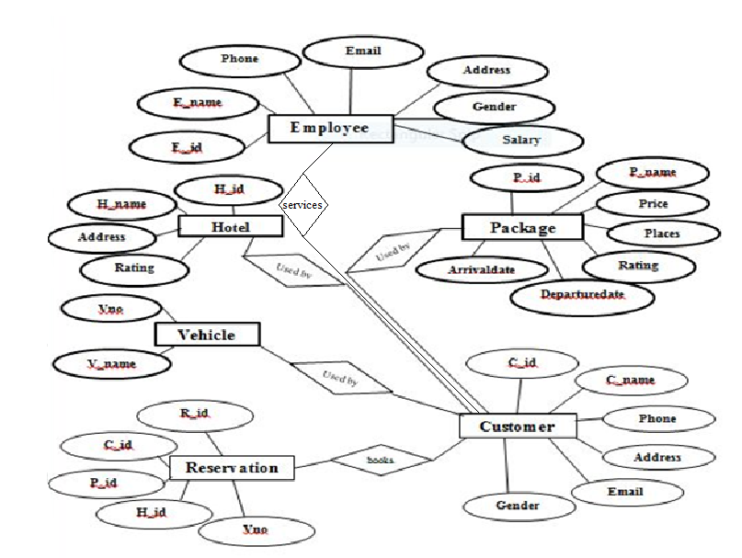

**4.2 Schema Diagram**

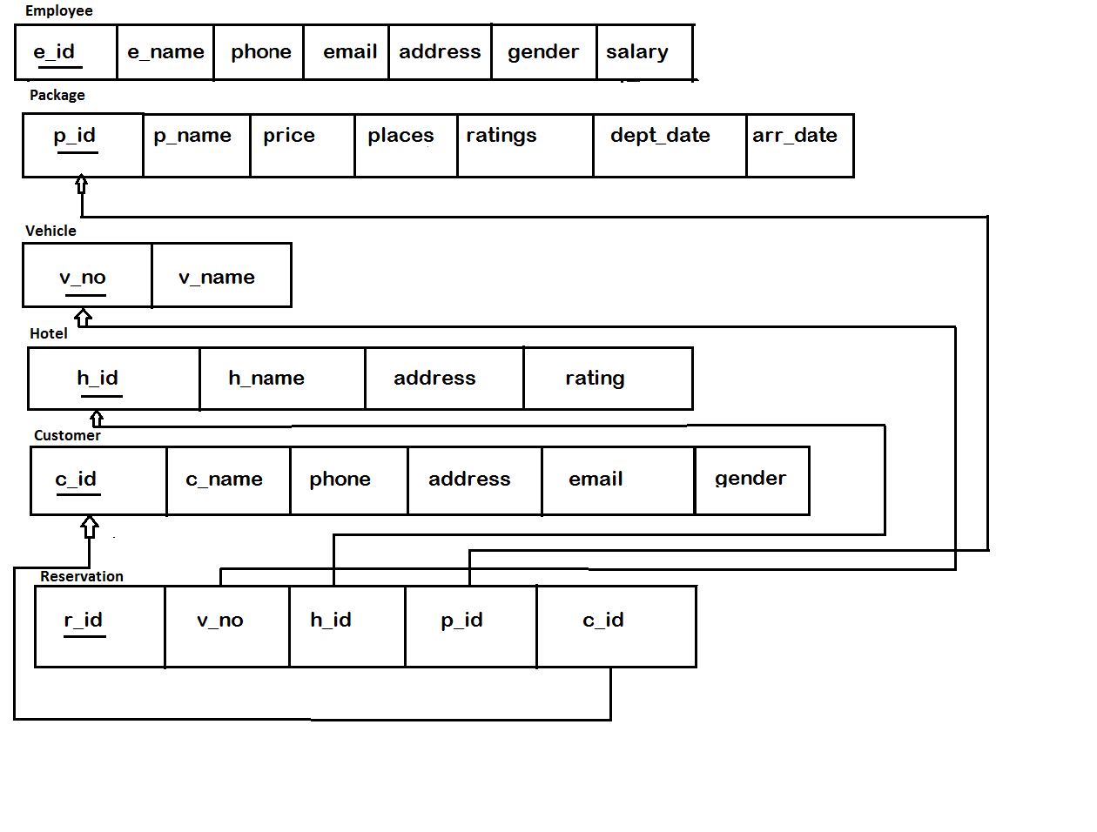

Table 4.2 schema diagram

**Chapter 5**

**SYSTEM IMPLEMENTATION**

**5.1Modules description**

**\*Create,** create table statement is used to create table to store data. Integrity constraints like primary key, foreign key, unique key, can be defined while creating the table.

**Create code for every table**

**Employee table**

Create table employee(

e_id varchar(4) primary key,

e_name varchar(15),

address varchar(15),

phone varchar(10),

email_id varchar(20),

gender varchar(10)

salary float );

**Package table**

Create table package(

p_id varchar(5) primary key,

p_name varcahr(15),

price integer,

places varchar(20),

rating integer,

departuredate,

arrivaldate);

**Vehicle table**

Create table vehicle(

v_no varchar(15) primary key,

v_name varchar(10));

**Hotel table**

Create table hotel(

h_id varchar(6) primary key,

h_name varcahr(15),

address varchar(15),

rating integer);

**Customer table**

Create table customer(

c_id varchar(8) primary key,

c_name varchar(15),

address varchar(20),

phone varchar(10),

email_id varchar(20),

gender char(6));

**Reservation table**

Create table reservation(

r_id varchar(10) primary key,

v_no varchar(10),

h_id varchar(6),

p_id varchar(5),

c_id varchar(8),

no_of_heads varchar(3),

foreign key (v_no) references vehicle(v_no) on delete cascade,

foreign key (h_id) references hotel(h_id) on delete cascade,

foreign key (p_id) references package(p_id) on delete cascade,

foreign key (c_id) references customer(c_id) on delete cascade);

**\*Insertion,** insertion is use to insert the tuple or row to the table. We insert value from frontend by making use HTTP the value inserted from to frontend will be going to store in backend database in XAMPPServer

**Insertion codes for every table**

**Employee table**

Insert into employee values (‘&e_id’, ’&e_name’, ’&address’, ’&phone’, ’&email_id’,

’&gender’, ‘&salary’);

**Package table**

Insert into package values (‘&p_id’, ’&p_name’, ‘&price’, ‘&places’, ‘&rating’,

‘&departuredate’ , ‘&arrivaldate’);

**Vehicle table**

Insert into vehicle values (‘&v_no’, ‘&v_name’);

**Hotel table**

Insert into hotel values (‘&h_id’, ‘&h_name’, ‘&address’, ‘&rating’);

**Customer table**

Insert into customer values (‘&c_id’, ‘&c_name’, ‘&address’, ‘&phone’, ‘&e_mail_id’,

‘&gender’);

**Reservation table**

Insert into reservation values (‘&r_id’, ‘&v_no’, ‘&h_id’, ‘&p_id’, ‘&c_id’, ‘&no_of_heads’);

**\*Update,** update will help to edit the tables in the database. In this project we have given update option for table package, to update the place column in package table.

**\*Delete,** delete will help us to delete a tuple or row from the table. In this project we have delete option for table employee to delete the particular row or employee information from the table.

**\* Trigger,** a trigger is a special kind of stored procedure that automatically executes when an event occurs in the database server. DML triggers execute when a user tries to modify data through a data manipulation language(DML) event. DML events are INSERT, UPDATE, OR DELETE statements on a table or view. In this project we added trigger on trigger on table package to give discount of 10% if the group has more than 10 travelers

**\*Stored procedure,** a stored procedure is a set of Structure Query Language(SQL) statements with an assigned name, which are stored in a relational database management system as a group, so it can be reused and shared by multiple programs. Stored procedure can access or modify data in a database, in this project we added stored procedure for table package to find income of our site.

**Chapter 6**

**SCREENSHOTS**

**6.1** **Welcome page**



Fig 6.1 **welcome page**

Welcome page helps us to add all the information about package, vehicle, hotel by employee. If anyone wills to work in this agency that person should register for agency.

Travel is experience of different kinds of feelings, travelling is not only in cost of visiting places but also it helps us to gain knowledge. If you wish to travel to different places with low cost, with attractive offers, then book here using go link for memorable time.

**6.2 Travel agency details**

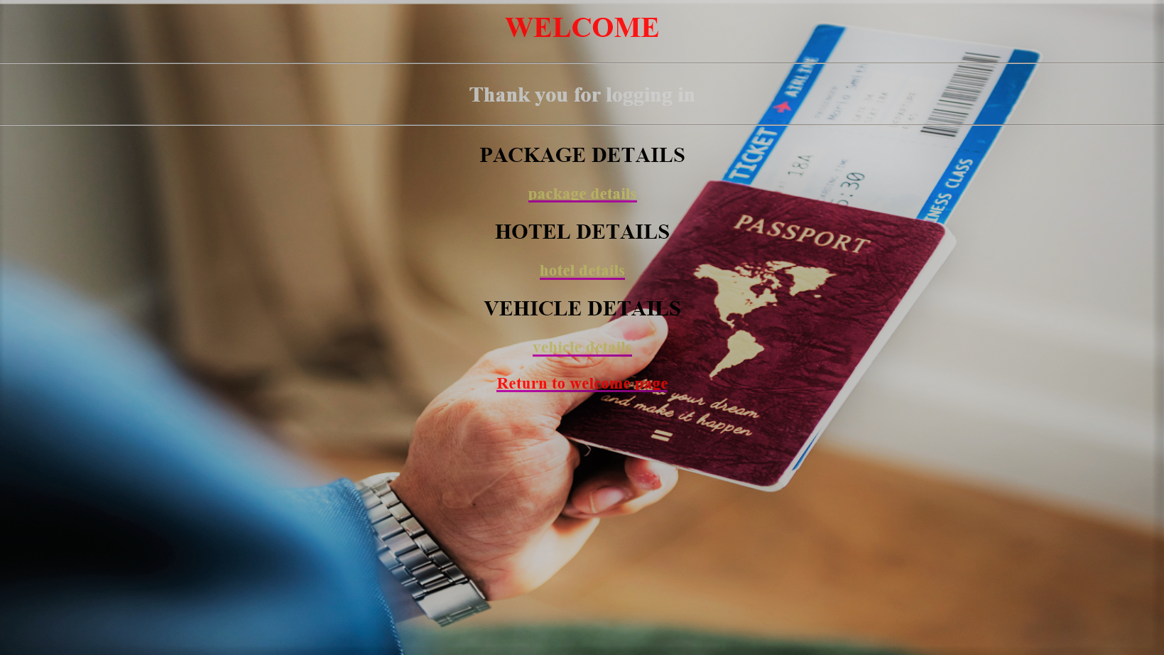

Fig 6.2 This page is accessed by the employee to enters the details about package, hotel, vehicle.

**6.3: Package Details**

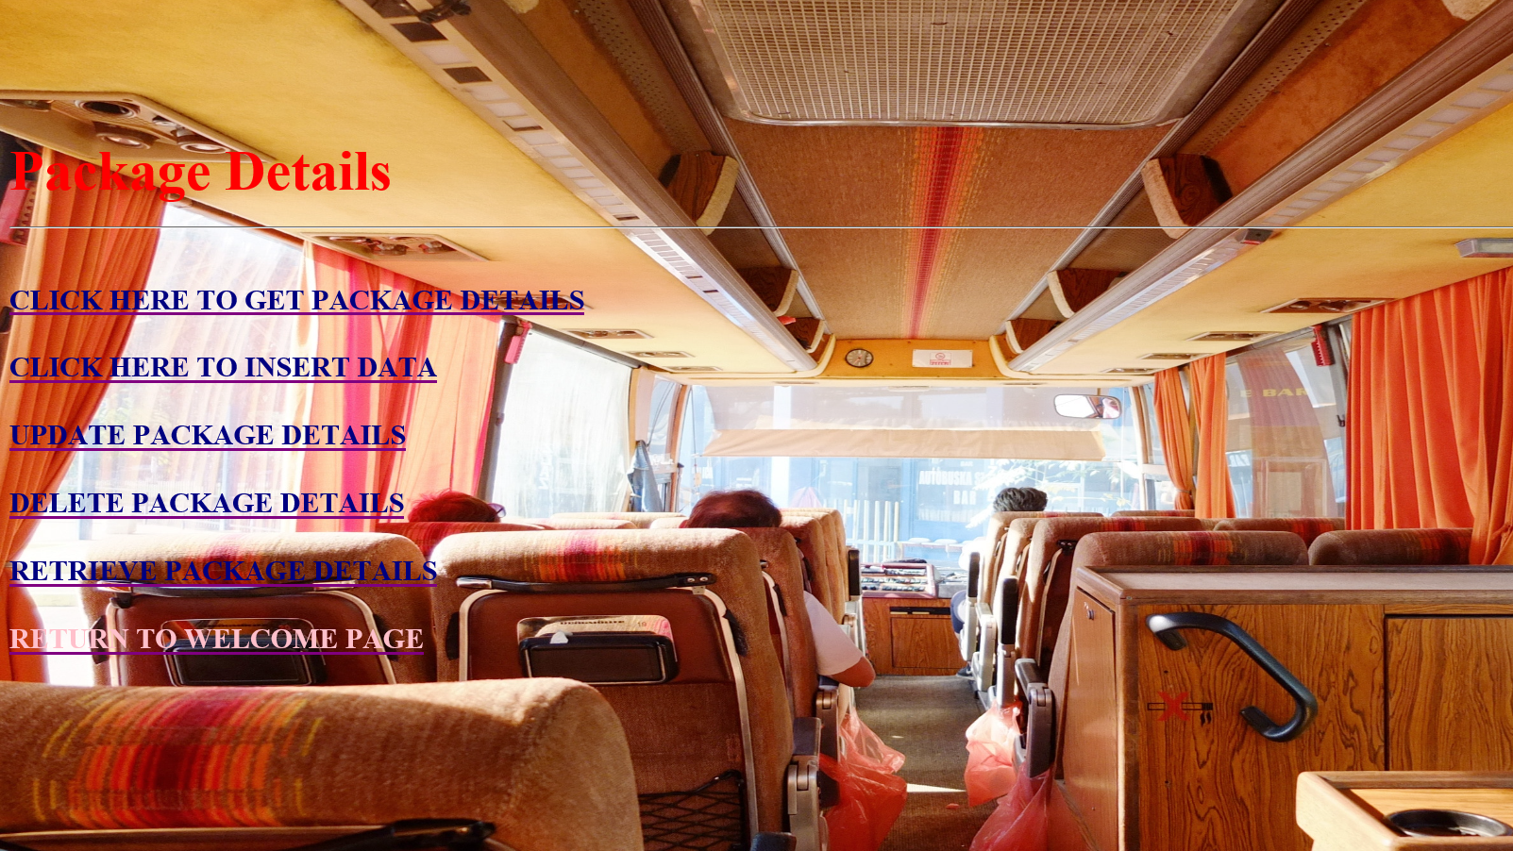

Fig 6.3 A package details are entered here by the employee this page is used to insert the package details

**6.4 Package insertion**

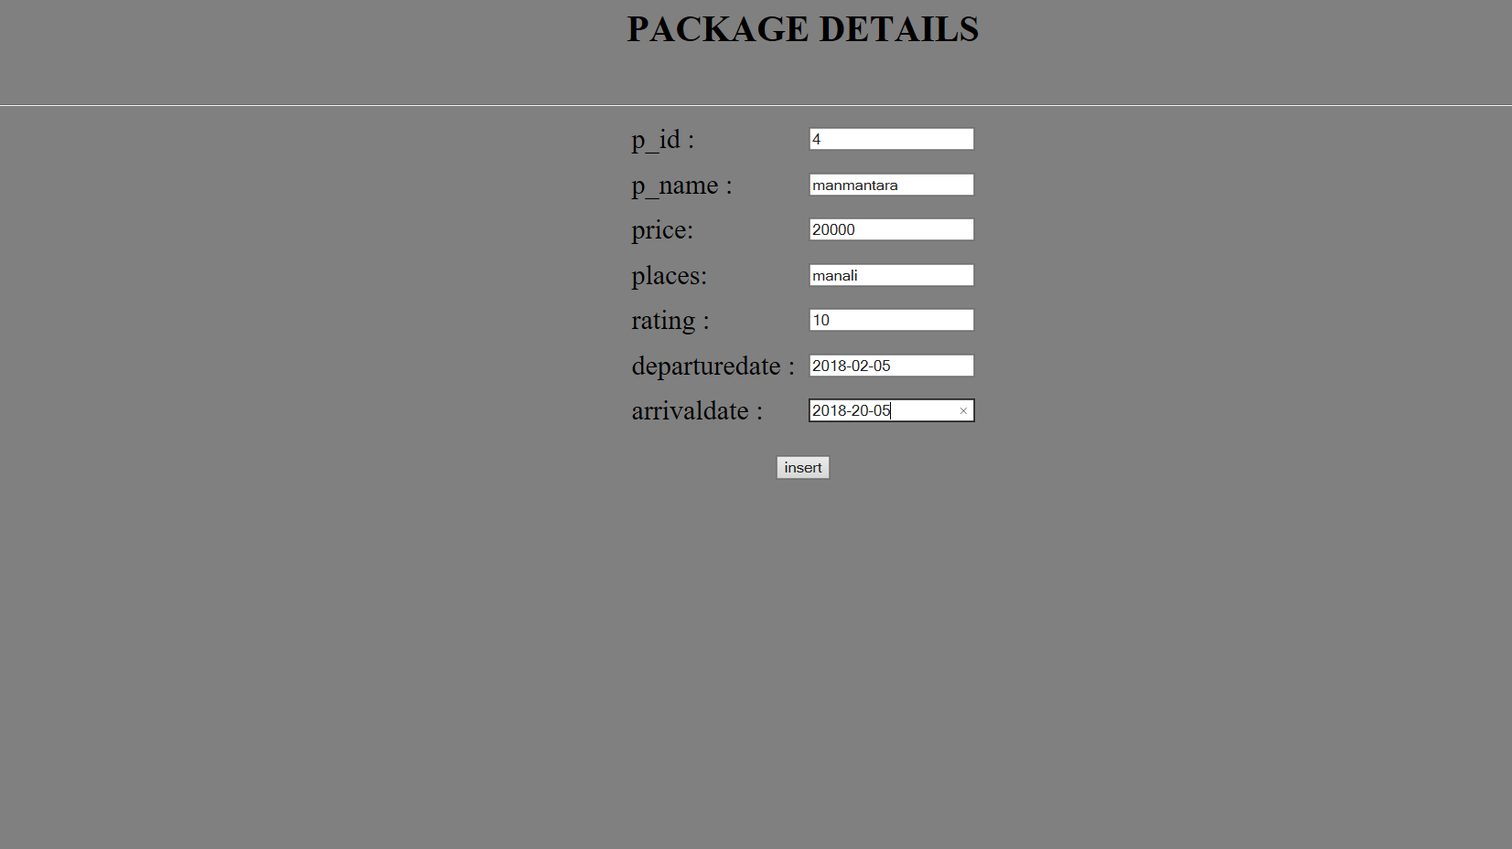

**Fig 6.4 demonstrates the process of inserting values into package table.**

**6.5 successful insertions**

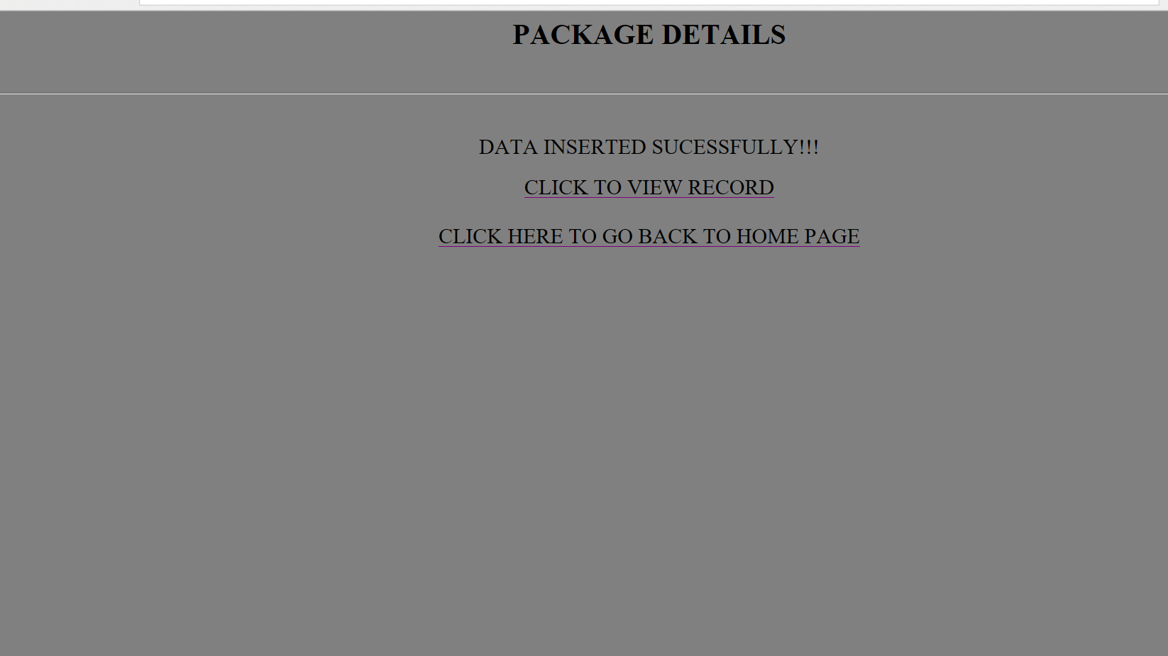

**Fig 6.5 successful insertion of data.**

**6.6 All Package details**

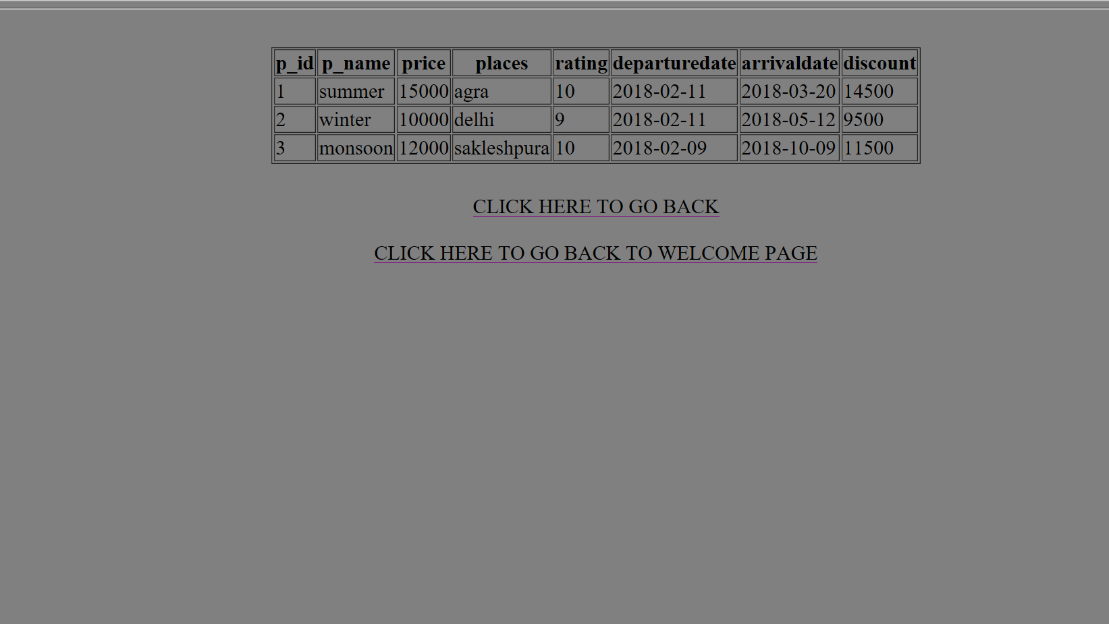

Fig 6.6 the above figure gives the details of all the packages that are available in the travel agency

**6.7 Update operation**

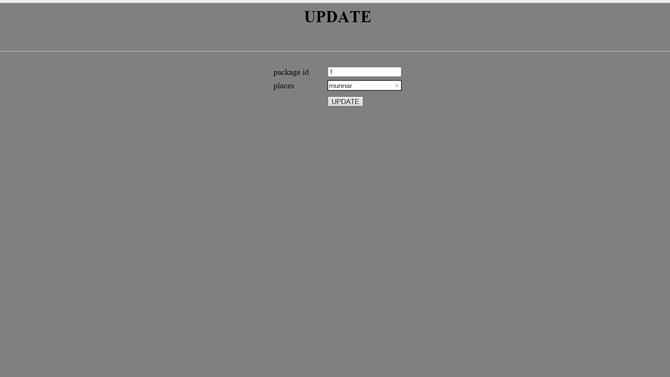

Fig 6.7 in the above fig update operation will take place to update column places in the table

**6.8 successful update**

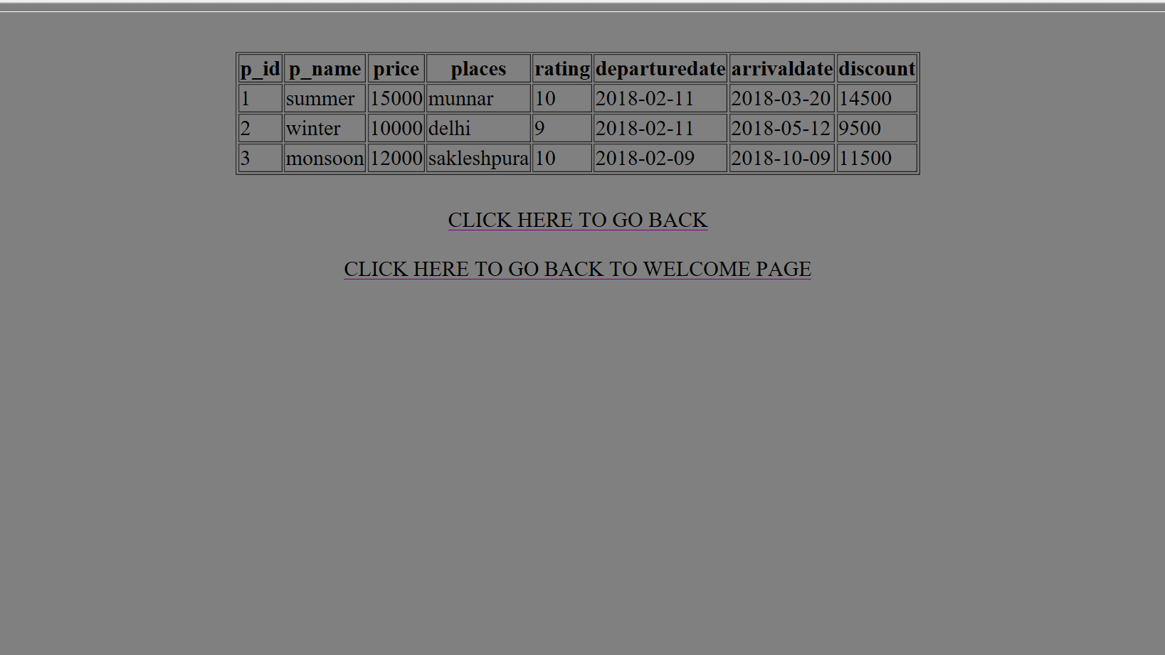

Fig 6.8 the above fig displays the information of the table after update operation, displays the updated information

**6.9 Delete operation**

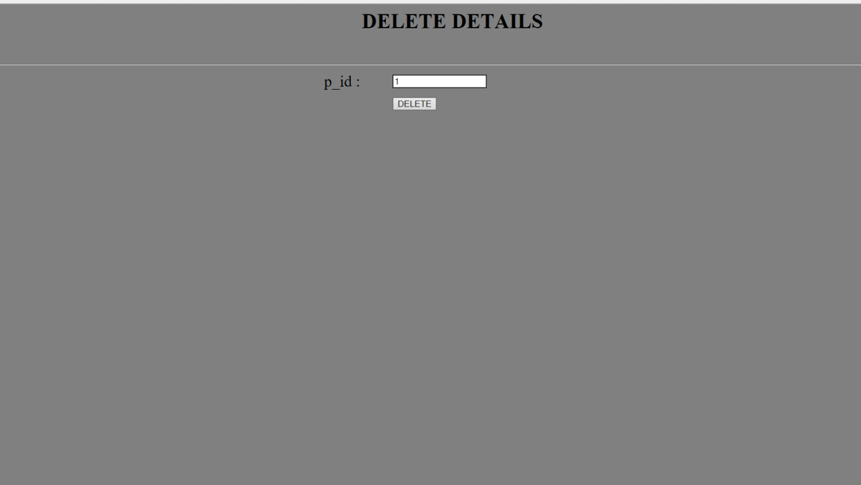

Fig 6.9 demonstrates deletion of a package id

**6.10 Successful deletion**

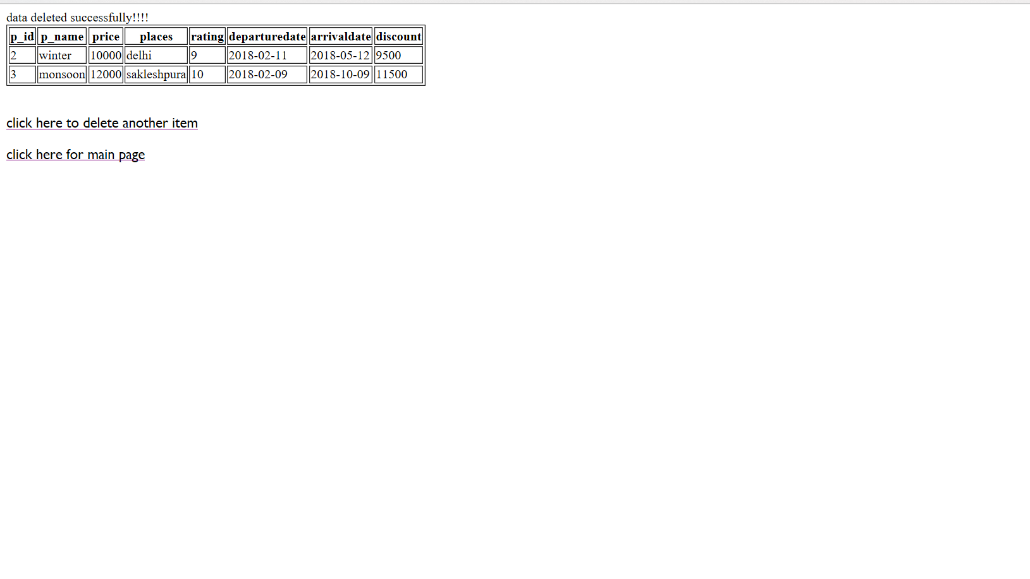Fig 6.10 the above fig gives the details of packages available after deletion

**6.11 Retrieval operation**

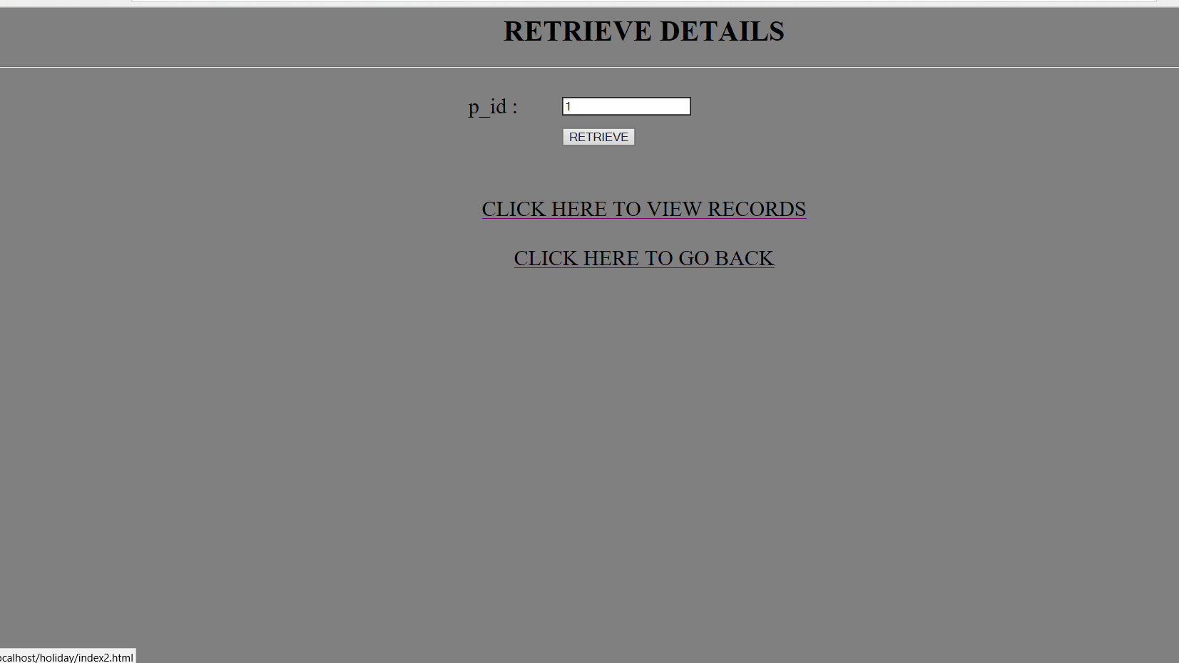

Fig 6.11 retrieving details of particular package

**6.12 Successful retrieval**

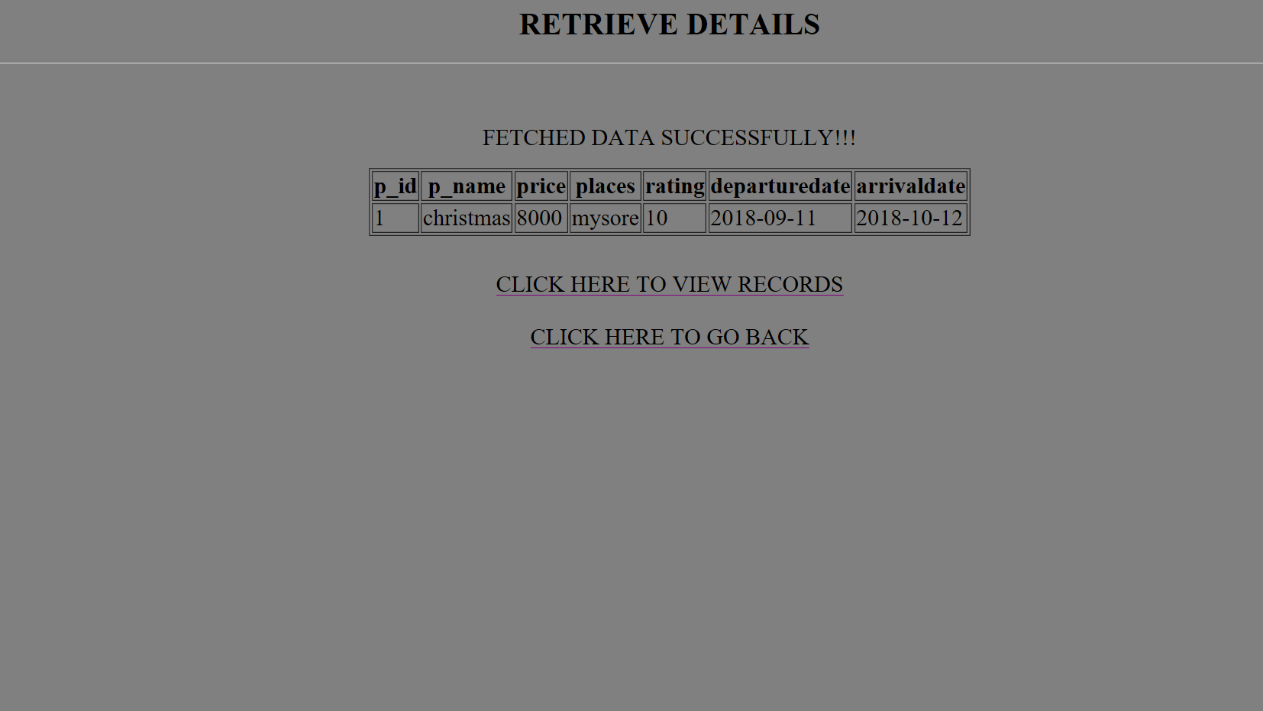

Fig 6,12 display retrieval of particular package details.

**Chapter 7**

**CONCLUSION**

To conclude the description about the project The project, developed using XAMPP Server with PHP & MySQL is based on the requirement specification of the users and analysis of the existing system, with flexibility for future enhancement.

HOLIDAY TOURS is very useful for travelers. This holiday tours software is designed for people who want to go trip for various places. For past few years the number of travel agencies are increasing rapidly. And hence there is a lot of strain on the person who is running travel agency and software are usually required in this context. This particular project deals with the problem on managing a travel agency

Identification of the drawbacks of the existing system leads to the design of computerized system that will be compatible to the existing system with the system which is more friendly

Travel agency normally make profit from their service charges. It is obviously to say that to rise the profit level they must need to rise sales volume. In addition with that, an estimation of costs and profits can also fix the target of monthly sales volume and monthly targeted commissions. However, suggested product development plan is suitable only if the company apply that accordingly their needs and customer interest. This is only suggested to the case company of future possibilities and scope of business.

Future work:

1.Implementatin of algorithm for planning of trip

2.Uses feedback based evolution of data base

3.News updates and flashes about the city through appropriate information source

**BIBLIOGRAPHY**

[1] [www.w3schools.com](http://www.w3schools.com)

[2] [www.php.net](http://www.php.net)

[3] [www.YouTube.com](http://www.YouTube.com)

[4] [www.quora.com](http://www.quora.com)

[5] [www.Wikipedia.org](http://www.Wikipedia.org)

[6] RamezElmasri and Shamkant B. Navathe, 7th edition, 2017, Person

|  |
| --- |
|  |
|  |
|  |
|  |
|  |
|  |
|  |

|  |
| --- |
|  |